  - Risk-Based Security Prioritization
A New Approach to Security Prioritization in Modern IT Environments Using Microsoft Defender

Introduction

Content
The Challenge: Too Many Security Recommendations 3
A Risk-Based Prioritization Model 3
Asset Criticality Model 3
Context-Based Risk Evaluation 4
Graph-Based Security Thinking 4
Business Benefits 4
Alignment with Regulations and Standards 4
Transparency and Flexibility in the Risk Model 4
Conclusion 5

The Challenge: Too Many Security Recommendations
Modern security platforms such as Microsoft Defender generate a very large number of security recommendations, vulnerabilities, and configuration findings.

Security teams are often faced with:
- thousands of vulnerabilities
- hundreds of security recommendations
- many findings marked as High or Critical

Although these tools are effective at identifying problems, they rarely answer the most important question: Which issues should be addressed first?

In practice, remediation work is often prioritized according to:
- technical severity
- number of affected systems
- ease of remediation

This often leads organizations to spend resources resolving issues with limited real risk while more critical exposures remain unaddressed.

Introduction
Modern organizations operate complex IT environments consisting of cloud resources, endpoints, identities and infrastructure systems.

Security platforms continuously generate large volumes of security data including vulnerabilities, configuration issues, security recommendations and exposure analysis.

While these tools are effective at identifying security problems, prioritization remains a significant challenge.

A Risk-Based Prioritization Model
The Security Insight framework introduces a risk-based prioritization model that evaluates security findings based on both consequence and probability.

Risk Score = Consequence Score × Probability Score

Consequence Score represents the potential impact if a vulnerability is exploited.
Probability Score represents the likelihood that the vulnerability will actually be exploited.

The model can also be influenced by contextual risk factors such as:
- internet exposure
- known exploits
- legacy systems.

Asset Criticality Model
Not all systems in an organization are equally important. Assets are therefore classified into 4 criticality tiers.
Criticality Level (Defender) | Tier | Category | Examples of systems
Critical / Very high | Tier-0 | Identity Control | Domain Controllers, Entra / Azure AD Sync, core authentication systems.
High | Tier-1 | Privileged Infrastructure | infrastructure servers, authentication systems, management platforms
Medium | Tier-2 | Business Systems | Employee workstations, application servers, collaboration systems
Low | Tier-3 | Low-Trust Systems | IoT devices, testing environments and specialized systems

Assets are automatically classified using tagging rules based on system roles.

Assets are classified using 2 methods in Defender Critical Asset Management:
- Automatic classification “Predefined classifications”
- Custom classification using tags in Defender & Azure

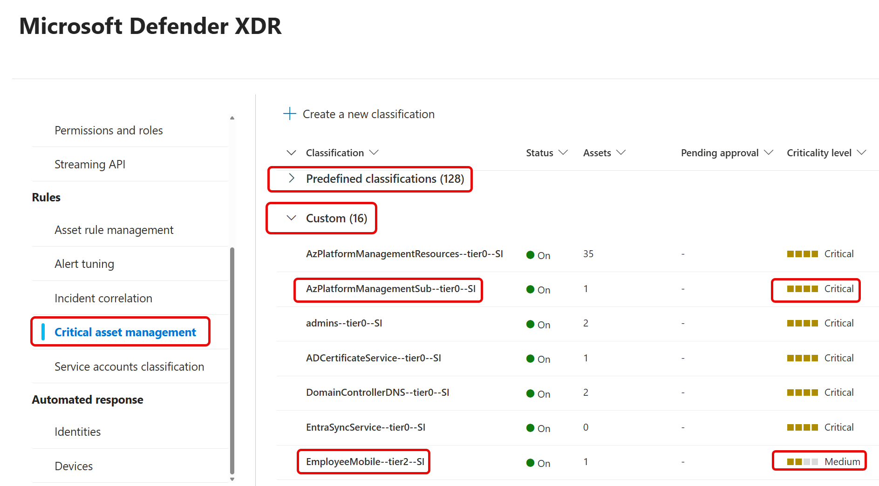

Custom classification in Defender Critical Asset Management
These classifications are translated into tier tags such as:
- AzPlatformManagementResources--tier0--SI
- DomainControllerDNS--tier0--SI
- ADCertificateService--tier0--SI
- EntraSyncService--tier0--SI
- EmployeeWorkstations--tier2--SI
- EmployeeMobile--tier2--SI
- IoT--tier3--SI
- AzHubPlatformManagementSub--tier0--SI
- AzHubPlatformSecuritySub--tier0--SI (custom detection)
- AzLZDatacenterSub--tier0--SI (custom detection)
- AutomationServer--tier0--SI (custom detection)
- ServerBusinessServices--tier1--SI (custom detection)
- PAWDevices--tier0--SI (custom detection)
- Network_Backbone_Switch--tier0--SI (custom detection)
- Network_Backbone_Router--tier0--SI (custom detection)
- Network_Backbone_Management--tier0--SI (custom detection)
- Network_WLANAccessPoint--tier2--SI (custom detection)
- Temp-Client-Devices--excluded--SI (custom detection)

The tags are used in the risk model when native criticality data is not available.

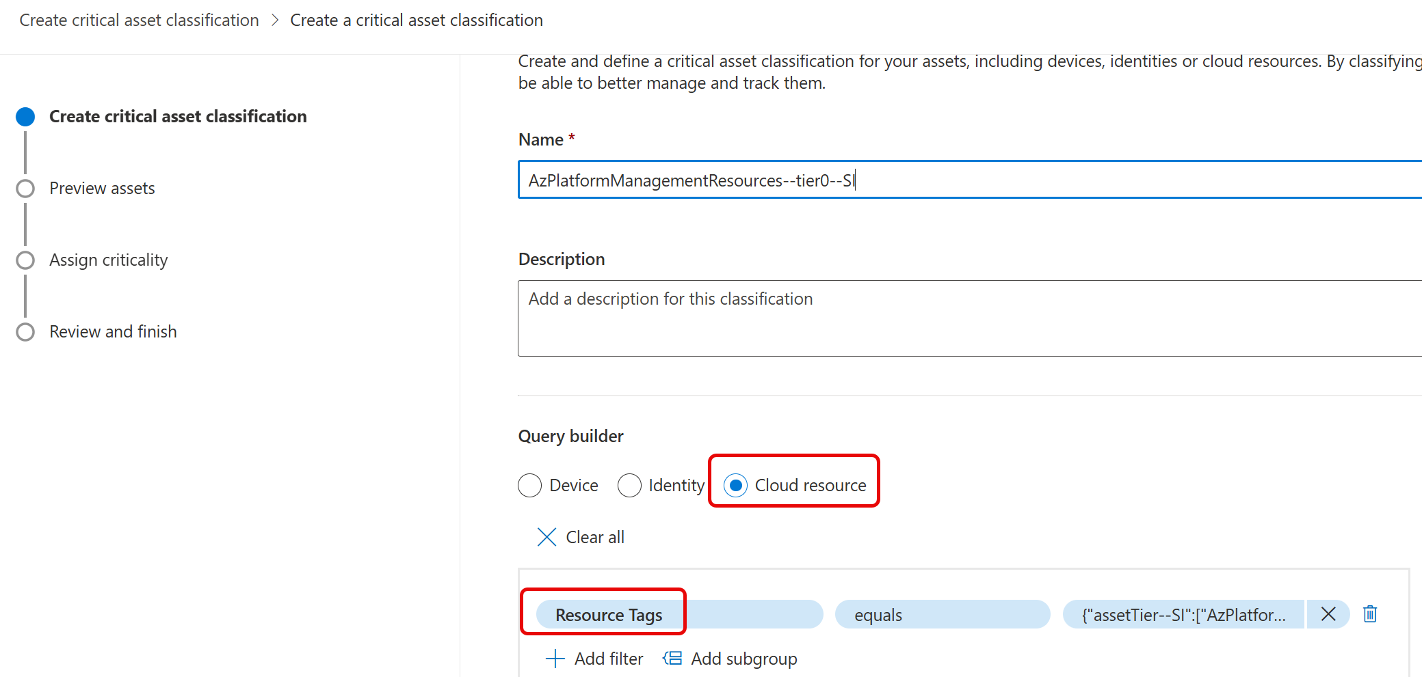

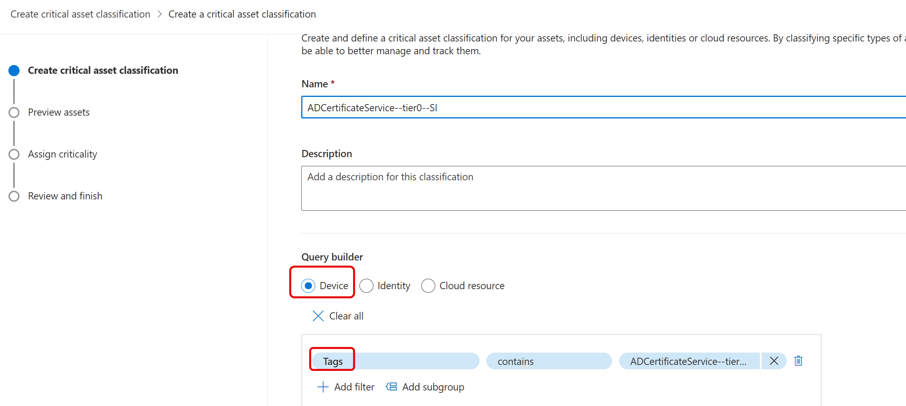

Example of query to detect Sentinel resources & set tag
AssetTagging:
- AssetTagName: AzPlatformManagementResources--tier0--SI
Mode: Prod
QueryEngine: AzureResourceGraph
Query:
- |
resourcecontainers
| where type == "microsoft.resources/subscriptions"
| join kind=inner (
resources
| where type == "microsoft.operationsmanagement/solutions"
| where name startswith "SecurityInsights("
| project subscriptionId
| distinct subscriptionId
) on subscriptionId
| extend
Tag_AssetTier = tostring(tags["AssetTier--SI"])
| extend
AssetTagType = "AssetTier--SI",
AssetTag = "AzPlatformManagementSub",
AssetTierLevel = 0
| extend
AssetTagName = strcat(AssetTag, "--tier", tostring(AssetTierLevel), "--SI")
| project
subscriptionId,
subscriptionName = name,
Tag_AssetTier,
AssetTagType,
AssetTag,
AssetTierLevel,
AssetTagName,
id
| order by subscriptionId asc
| where Tag_AssetTier != AssetTagName

Context-Based Risk Evaluation
In addition to asset tier, contextual factors are evaluated such as exploit availability, internet exposure, and legacy operating systems.

These factors increase the probability of exploitation and therefore influence the overall Risk Score.

Exposure Graph Architecture
Attackers do not think in lists of vulnerabilities. They think in relationships between systems.

A typical attack path may move through several systems:
User device → Application server → Service account → Domain Controller

The Security Insight model therefore uses Exposure Graph analysis to identify relationships between assets, identities, vulnerabilities and configuration issues. Data is coming from:

- ExposureGraphNodes
- ExposureGraphEdges
- Defender Vulnerability Management findings
- configuration assessments

These datasets allow analysis of relationships between systems and security findings.

Asset Classification
Assets are automatically classified using tagging rules based on system roles.

Examples include:
- Domain Controllers
- Entra synchronization services
- employee devices
- IoT devices

These classifications are translated into tier tags such as:
- AzPlatformManagementResources--tier0--SI
- DomainControllerDNS--tier0--SI
- ADCertificateService--tier0--SI
- EntraSyncService--tier0--SI
- EmployeeWorkstations--tier2--SI
- EmployeeMobile--tier2--SI
- IoT--tier3--SI
- AzHubPlatformManagementSub--tier0--SI
- AzHubPlatformSecuritySub--tier0--SI (custom detection)
- AzLZDatacenterSub--tier0--SI (custom detection)
- AutomationServer--tier0--SI (custom detection)
- ServerBusinessServices--tier1--SI (custom detection)
- PAWDevices--tier0--SI (custom detection)
- Network_Backbone_Switch--tier0--SI (custom detection)
- Network_Backbone_Router--tier0--SI (custom detection)
- Network_Backbone_Management--tier0--SI (custom detection)
- Network_WLANAccessPoint--tier2--SI (custom detection)
- Temp-Client-Devices--excluded--SI (custom detection)

The tags are used in the risk model when native criticality data is not available.

Risk Score Model
Risk Score is calculated using two dimensions:

Consequence Score – the potential impact if exploitation occurs.
Probability Score – the likelihood of exploitation based on asset tier and exposure context.

Risk Factors
Probability Score may be adjusted using contextual risk indicators such as:
- exploit availability
- internet exposure
- legacy systems

These factors increase the likelihood of exploitation.

Risk Calculation
The final risk score is calculated as:

Risk Score = Consequence Score × Probability Score

This score is used to prioritize remediation activities.

Reporting
The framework generates both summary and detailed reports.

Summary reports include:
- number of findings per tier
- overall risk levels
- configuration status

Detailed reports include affected assets, vulnerability identifiers and remediation guidance.

Implementation Architecture
The solution consists of three main components:

Data Collection
- Microsoft Defender
- Exposure Graph
- Azure Resource Graph

Analysis
- Kusto queries
- YAML report definitions
- risk score calculations

Output
- Excel reports
- dashboards
- prioritized remediation lists.

Governance and Compliance
The model supports several regulatory and security frameworks including:
- NIS2 Directive
- CIS Critical Security Controls
- ISO 27001 risk management principles.

Operational Benefits
Organizations implementing the model gain:
- improved vulnerability prioritization
- reduced remediation backlog
- improved visibility into attack paths.

Future Opportunities
Potential future developments include:
- automated attack path analysis
- integration with threat intelligence
- integration with ticketing and risk management platforms.

Transparency and Flexibility
The Security Insight architecture is fully open and transparent and is based on:

- PowerShell automation
- Kusto Queries for data analysis
- CSV files defining scoring models
- YAML report definitions
- asset tagging

This ensures the prioritization model can be inspected, validated and adapted to organizational requirements.

Collaboration with Microsoft
The development of the Security Insight model is conducted in close dialogue with Microsoft.

Morten Knudsen collaborates with Microsoft, including Raviv Tamir, Corporate Vice President for Microsoft Defender, and his team to explore how the risk-based prioritization concepts can influence the future strategy of the Microsoft Defender platform.

Summary
The Security Insight model focuses on transparency, flexibility and openness.

By building the solution on open technologies organizations can fully understand and adjust the risk model according to their own priorities and security strategy.

